Data Structures & Algorithms (CSC-214) Semester: Spring 2025
Instructor: Hamna Anwar Date: 28th Feb 2025
Lab 3: searching and sorting arrays

Graded Lab 3
Objective: The goal of this lab is to reinforce the concepts of array searching and sorting in C++.

Instructions: Download the given code which gives a partial implementation and test driver program (main) for the class AlphabetArrayList. AlphabetArrayList is a list of alphabets maintained in an array. The partial implementation is explained where needed with comments. The code for the following four member functions is missing. The code will compile and run, but will not produce results for the four functions. Write down the code for the four functions and use the test program to confirm that it works.

Note: Do not change any of the other code, because your code will be checked by copying and inserting into the original .cpp file that has been given to you.

void countVowels()
Counts and returns the number of vowels (a, e, i, o, u) present in the array.

int findLastIndex(char)
Finds and returns the index of the last occurrence of a given character. Returns -1 if the character is not found.

void swapElements(int, int)
Swaps the elements at two given indices in the array.

void mergeFirstN(const AlphabetArrayList&, int)
Merges only the first N elements of the second list into the first list.
Merges the first N values from the list received as the parameter into the list; note that to implement this, you will need to save a copy of the original list, deallocate its memory, reallocate enough new memory to hold values from both lists, and then copy both sets of values into the new memory. The capacity of the updated list will be the sum of the capacity of both lists. Capacity should be shown clearly as per the sample output.

Bonus marks(only if marks are being deducted elsewhere):
void sortedMerge(const AlphabetArrayList&)
Merges two lists in sorted order, creating a combined sorted array without modifying the original lists.

Sample run:

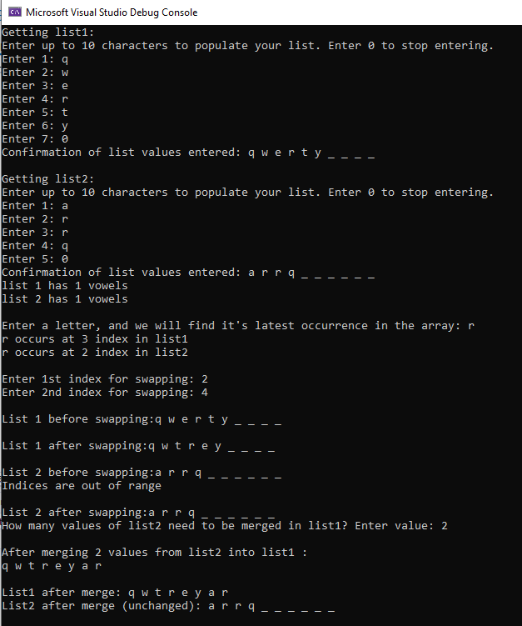

Code for merging arrays has been provided below:

#include <iostream>
using namespace std;

/*
Lab: Dynamic Array Merging
Objective:
- To practice dynamic memory allocation in C++.
- To merge two arrays into a third dynamically allocated array.
- To properly manage memory by releasing the original arrays after merging.
*/

int main() {
int size1, size2;

// Get the size and elements for the first array
cout << "Enter the number of elements for the first array: ";
cin >> size1;
int* array1 = new int[size1];
cout << "Enter " << size1 << " integers for the first array:" << endl;
for (int i = 0; i < size1; i++) {
cin >> array1[i];
}

// Get the size and elements for the second array
cout << "\nEnter the number of elements for the second array: ";
cin >> size2;
int* array2 = new int[size2];
cout << "Enter " << size2 << " integers for the second array:" << endl;
for (int i = 0; i < size2; i++) {
cin >> array2[i];
}

// Allocate memory for the merged array
int mergedSize = size1 + size2;
int* mergedArray = new int[mergedSize];

// Copy the first array into the merged array
for (int i = 0; i < size1; i++) {
mergedArray[i] = array1[i];
}
// Copy the second array into the merged array
for (int i = 0; i < size2; i++) {
mergedArray[size1 + i] = array2[i];
}

// Free the memory for the original two arrays
delete[] array1;
delete[] array2;

// Display the merged array
cout << "\nThe merged array is:" << endl;
for (int i = 0; i < mergedSize; i++) {
cout << mergedArray[i] << " ";
}
cout << endl;

// Release the memory for the merged array
delete[] mergedArray;

return 0;
}

BONUS Question sample run:

